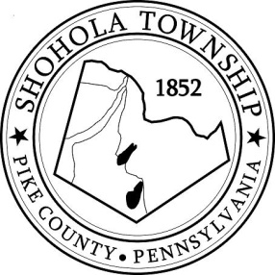
SHOHOLA TOWNSHIP BOARD OF SUPERVISORS
159 Twin Lakes Road
MUNICIPAL BUILDING, SHOHOLA, PA, 18458

AGENDA
November 10, 2022
ATTENDANCE

MEETING CALLED TO ORDER - PLEDGE ALLEGIANCE TO THE FLAG

APPROVAL OF MINUTES: Motion to approve Minutes of the the Regular Meeting of the Board on October 13, 2022.

APPROVAL OF EXPENDITURES: Motion to approve expenditures for October 2022.

APPROVAL OF TREASURERS REPORT: Motion to approve Treasurer’s Report October, 2022.

PLANNING COMMISSION:
- Hickler & Kleinger Lot Line Adjustment
- Geitz Subdivision and Lot Consolidation Plan

SOLICITORS REPORT:
- Public hearing advertisement requirements.

ANNOUNCEMENTS

OLD BUSINESS:
- 2023 Budget

NEW BUSINESS:
- Auditors Contract for 2023
- Public hearing advertisement requirements

CORRESPONDENCE:
- Letter from Nature Conservancy regarding 130 acre property purchase.

REPORTS TO TH E BOARD
- Building Permits 7 Residential permits for Residential permits for October, 2022
- Zoning and Sewage 11 Sewage Permits, 10 and Zoning Permits issued in October, 2022.
- Road Department
- Park Committee
- Fire Department

SUPERVISORS COMMENTS:

PUBLIC COMMENTS:

